**MAKERERE  UNIVERSITY**

**SMART HOME SYSTEM**

By

BSE 20-43

EMBEDDED SYSTEM

DEPARTMENT OF NETWORKS

SCHOOL OF COMPUTING AND INFORMATICS TECHNOLOGY

A Project Report Submitted to the School of Computing and Informatics Technology

for the Study Leading to a Project in Partial Fulfilment of the

Requirements for the Award of the Degree of Bachelor of

Science in Software Engineering of Makerere University.

Supervisor

Dr. Agaba Joab Ezra

Department of Networks

School of Computing and Informatics Technology, Makerere University

jagaba@cis.mak.ac.ug, +256-41-540628, Fax: +256-41-540620

October,2020

# DECLARATION

We, group BSE 20-43, hereby declare that the work presented is original and has never been submitted for an award to any university or institution of higher learning.

|  |  |  |  |  |
| --- | --- | --- | --- | --- |
| # | Names | Registration Number | Student Number | Signature |
| 1 | Thakkar Brinda Sanjaykumar | 16/X/2271/PS | 216002450 |  |
| 2 | Waiswa Brian Victor | 16/U/1254 | 216000402 |  |

# APPROVAL

This project report titled SMART HOME SYSTEM has been submitted for examination with my approval as the supervisor of group BSE 20-43.

Dr. Agaba Joab Ezra

Department Of Networks

School of Computing and Informatics Technology;

College of Computing and Information Sciences,

Makerere University

Signature: ................................................... Date: ............................

Supervisor

# DEDICATION

We dedicate this project to God Almighty. We dedicate this project to COCIS College which provided us the funds for making the implementation of this system possible.

# ACKNOWLEDGEMENTS

We would like to express our sincere gratitude to several individuals and MAKERERE UNIVERSITY and COCIS College for supporting us throughout our Graduate study. We would like to thank COCIS for providing us with the necessary components for our project.

First, we express our sincere gratitude to our chief supervisor Dr. Mary Nsabagwa, for her continuous ideas, practical advice, insightful comments, motivation and all kind support and guidance throughout the whole project. Due to her immense knowledge, profound experience and professional expertise in embedded system has enabled us to successfully complete this project.

We would also like to express our gratitude to our Supervisor Dr. Agaba Joab, for his ideas, guidance and support throughout the whole project.

# ABSTRACT

This report presents the overall design and implementation of the Smart Home System. This system is designed to improve the standard of living for the users at their homes to ease their lifestyle.

The system comprises of 3 main components: mobile application, the sensors and the Arduino. The mobile application is used to control and monitor the home appliances through the Arduino using wireless connection. The sensors gives the status of the different home appliances on the mobile application.

The system is intended to control home appliances in the house with relatively low cost design, user – friendly interface and ease of installation.

**Table of contents**

Software design document…………………………………………..1

Software project report …………………………………………….22

User manual……………………………………………………........40

**OUR PROJECT BLOG**

**BSE20-43**

**LINK:** [softwaredev91930750.wordpress.com](http://softwaredev91930750.wordpress.com)

**SMART HOME SYSTEM**

**SOFTWARE DESIGN DOCUMENT**

**12TH FEBRUARY 2020**

Table of Contents

1. INTRODUCTION 1

1.1 PURPOSE 1

1.2 SCOPE 1

1.3 OVERVIEW 1

1.4 REFERENCE MATERIAL 2

1.5 DEFINITIONS AND ACRONYMS 2

2. SYSTEM OVERVIEW 3

3. SYSTEM ARCHITECTURE 4

3.1 ARCHITECTURAL DESIGN 4

3.2 DECOMPOSITION DESCRIPTION 5

3.2.1 ARDUINO UNO MICRO-CONTROLLER 5

3.2.2 LIGHT SENSOR 6

3.2.3 TEMPERATURE SENSOR 6

3.2.4 MOTION SENSOR 7

3.2.5 SMOKE SENSOR 7

3.2.6 MOBILE APPLICATION 8

3.2.7 DATABASE 8

3.2.8 TOP LEVEL DATA FLOW DIAGRAM FOR THE SMART HOME SYSTEM 9

3.3 DESIGN RATIONALE 9

4. DATA DESIGN 10

4.1 DATA DESCRIPTION 10

4.2 DATA DICTIONARY 11

5. COMPONENT DESIGN 12

5.1 LIGHT CONTROL 12

5.2 MOTION DETECTION 12

5.3 TEMPERATURE CONTROL 12

5.4 ALARM AND SMOKE DETECTION 12

5.5 MOBILE APPLICATION 13

5.6 DATABASE 13

6. HUMAN INTERFACE DESIGN 14

6.1 OVERVIEW OF USER INTERFACE 14

6.2 SCREEN IMAGES 16

6.2.1 LOGIN SCREEN 16

6.2.2 INTERFACE FOR LIGHTS CONROL 17

6.2.3 INTERFACE FOR DOORS 18

6.2.4 INTERFACE FOR FAN 19

6.3 SCREEN OBJECTS AND ACTIONS 20

7. REQUIREMENTS MATRIX 21

**LIST OF FIGURES**

Figure 3. 1 System Architecture 4

Figure 3. 2 Arduino UNO Micro-controller 5

Figure 3. 3 Light sensor 6

Figure 3. 4 Temperature sensor 6

Figure 3. 5 Motion sensor 7

Figure 3. 6 Smoke sensor 7

Figure 3. 7 Mobile application 8

Figure 3. 8 Data Flow Diagram 9

Figure 6. 1 Use case diagram 14

Figure 6. 2 Login interface 16

Figure 6. 3 Interface for lights 17

Figure 6. 4 Interface for controlling doors 18

Figure 6. 5 Interface for controlling fan 19

**LIST OF TABLES**

Table 4.1 The data types and description for the sensors 10

Table 4.2 Data description for the log in activity 11

Table 4.3 Data description for the status report activity 11

Table 6.1 Use case description 15

Table 7. 1 Cross-reference of system components and functional requirements 21

# INTRODUCTION

## 1.1 PURPOSE

This software design document provides description for the design and architecture of the Smart Home System, for the software developers and other technical users of the system to understand what is to be built and how it is supposed to be built. It also provides detailed information of the system to be built. This document is intended for developers, testers and project managers to understand the system to be built.

## 1.2 SCOPE

This system will focus primarily on automating the process of switching on and off of lights, opening and closing of doors, and switching on and off of different home appliances like fans, coolers, alarms, smoke detection and temperature control for houses that are going to use this system.

This system will help users to have their homes automated and live an easy and comfortable life. The main objective of this system is to improve the quality of life and the convenience at home for the users of this system. Life will be easier for the users of this system as most of the home appliances will be automated and it will also save their time.

## 1.3 OVERVIEW

The SDD is divided into different sections with various sub sections under those sections.

**Introduction** – it provides the purpose, the goal, objectives, benefits, intended audience and references.

**System overview** – it includes the description of functionality and design of the system.

**System architecture** – it explains the relationships between each module and also provides a decomposition of subsystems.

**Data design** – explains how the information is transformed into data structures.

**Component design** – it describes the algorithm and its procedure, functions of each object

**Interface design** – it shows the functionality of the system from the user’s perspective.

## 1.4 REFERENCE MATERIAL

The project concept paper

The project System Requirements Specification Document

The SDD template

## 1.5 DEFINITIONS AND ACRONYMS

SDD – Software Design Document

# SYSTEM OVERVIEW

In Uganda today, most people control their appliances manually and they need a way to automate the activities in their homes to make their life easy and comfortable. The proposed system will address the problem of the managing and controlling of the home activities manually.

Smart Home system is a generic solution that will automate the process of the usage and control of different home appliances and will add an extra layer of security to the home. The system will work automatically through use of different sensors like light sensors, motion detectors, temperature sensors which data will trigger certain events turning on and off of lights, turning on and off of fans, opening and closing of doors. The client will also have the ability to override the system through use of a mobile application after being authenticated and authorized by the system.

# SYSTEM ARCHITECTURE

## ARCHITECTURAL DESIGN

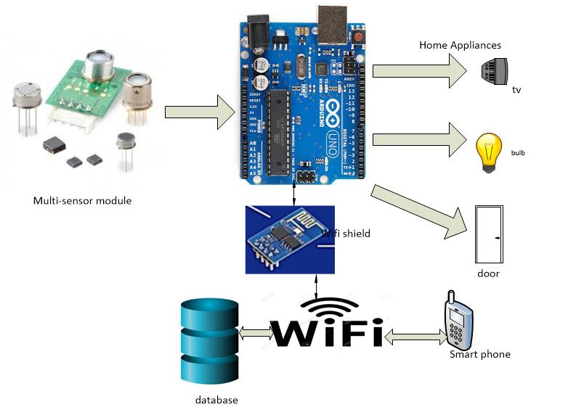

Figure 3. 1 System Architecture

This section shows the architecture design for the Smart home system. The system will consist of four major components which will form a complete smart home system.

Arduino UNO micro-controller will control all the functions and interactions between the sensors, home appliances and the mobile application. It will also send signals to different home appliances after receiving the status reports from the sensors.

The sensors are very important component of the system as it will help the Arduino UNO to control the switching on/off of the different home devices using the light sensor, temperature sensor, motion sensor, smoke sensor. It will also trigger the alarm whenever it receives signal from the smoke sensor.

Home appliances are another main component of the system as the Arduino UNO will interact with them to perform different functions.

Mobile application is a small but important component of the system as it will be used to login to the system to perform different functions such as switching on/off lights, fans, etc. through wireless connection.

Database will also be a part of the system as it will store the user login information and records of the sensors.

## DECOMPOSITION DESCRIPTION

### ARDUINO UNO MICRO-CONTROLLER

Arduino UNO micro-controller will be used to process data received from the sensors and it will also interact with the home appliances and the mobile application.

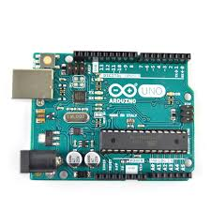

Figure 3. 2 Arduino UNO Micro-controller

### 3.2.2 LIGHT SENSOR

The light sensor will detect light and will send signals to Arduino UNO so that it can handle the switching on/off of the lights.

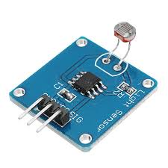

Figure 3. 3 Light sensor

### 3.2.3 TEMPERATURE SENSOR

It will detect the level of temperature in the surrounding environment and send signals to Arduino UNO to switch on/off the fans.

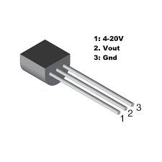

Figure 3. 4 Temperature sensor

### 3.2.4 MOTION SENSOR

It will detect the movement in the house and will send signal to the Arduino UNO and it will handle the opening and closing of the doors accordingly.

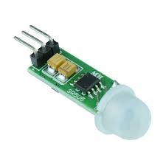

Figure 3. 5 Motion sensor

### 3.2.5 SMOKE SENSOR

It will detect the smoke in the house and also the fire and it will send signals to the Arduino UNO which will trigger the alarm to inform the user about the fire in the house.

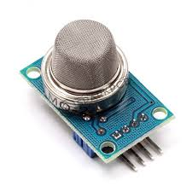

Figure 3. 6 Smoke sensor

### 3.2.6 MOBILE APPLICATION

The mobile application will be used to communicate with the system and home appliances by the user to choose which device he/she wants to interact with at any time they want.



Figure 3. 7 Mobile application

### 3.2.7 DATABASE

The database will store the user information entered by the users in the mobile application to keep record of the personal information and to restrict any unauthenticated user to interact with the system. It will also store the data received from the different sensors.

### 3.2.8 TOP LEVEL DATA FLOW DIAGRAM FOR THE SMART HOME SYSTEM

The proposed system will interact with entities such as sensors, home appliances and the mobile application as shown in the Figure 3.8. In this the different sensors will capture parameters from the surrounding environment and will be sent to the Smart home system which will use the Arduino UNO to interact with different home appliances. The mobile application will also be used to interact with the home appliances through the Arduino UNO using the wireless connection.

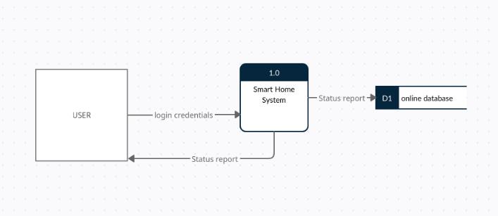

Figure 3. 8 Data Flow Diagram

## 3.3 DESIGN RATIONALE

We are using the Arduino UNO micro-controller as it is very effective and efficient to use while we interacting with sensors and different devices and it is easy to do programming with it.

We used a mobile application in order to interact with home appliances which will help the user to easily choose which device they want to control at any time they want. The mobile application will be connected to a database in order to capture the user login details.

# 4. DATA DESIGN

## 4.1 DATA DESCRIPTION

The proposed Smart home system will have four types of sensors;

Light sensors which will detect the light and will turn on/off the lights accordingly and will output the resistance and the Arduino will store it in the database.

Temperature sensor will detect the temperature and will be used to control the level of hotness, coolness and humidity in the house. It will also send signals to other devices in order to turn on/off the fans. It will send the Celsius degrees to the Arduino. And the Arduino will store it in the database.

Motion sensors will detect the movement in the house and will send signal and trigger the alarm. It will send the output voltage to the Arduino. And the Arduino will store it in the database.

Smoke sensors will detect the smoke levels or fire in the house and it will send signal to the alarm. It will send the output voltage to the Arduino. And the Arduino will store it in the database.

Table 4.1 The data types and description for the sensors

|  |  |  |  |  |
| --- | --- | --- | --- | --- |
| Parameter | | Data type | Length | Description |
| Light sensor | | Integer | 15 | Will capture and store the resistance in the database |
| Temperature sensor | Degrees | Integer | 15 | Will capture the temperature and store the converted degrees in the database |
| Motion sensor | | Integer | 15 | Will capture the voltage and store it in the database |
| Smoke sensor | | Integer | 15 | Will store the converted voltage in the database |

## 4.2 DATA DICTIONARY

The proposed Smart home system also has mobile application which will be used to interact with the system in order to control all the devices.

When the user opens the mobile application he/she needs to login to the system with a username and password. All the usernames and passwords will be converted to varchar data type and will stored in the database.

The table below has the data description for the log in activity.

Table 4.2 Data description for the log in activity

|  |  |  |  |
| --- | --- | --- | --- |
| Field Name | Data type | Field Size For Display | Description |
| Username | Varchar | 30 | User’s name |
| Password | Varchar | 30 | Password for the user |

The table below is for the status report activity.

Table 4.3 Data description for the status report activity

|  |  |  |  |
| --- | --- | --- | --- |
| Field Name | Data type | Field Size For Display | Description |
| Temperature | Integer | 15 | Temperature status |
| Motion | Varchar | 30 | Motion status |
| Door | Varchar | 30 | Door status |
| Fan | Varchar | 30 | Fan status |
| Smoke | Varchar | 30 | Smoke status |
| Bulb | Varchar | 30 | Bulb status |
| Alarm | Varchar | 30 | Alarm status |

# 5. COMPONENT DESIGN

## 5.1 LIGHT CONTROL

This pseudocode controls the functions of the lights.

If the light sensor detects light,

Then turn off lights;

Else turn on lights;

## 5.2 MOTION DETECTION

This pseudocode controls the functions for movement in the house.

If the sensor is on;

Then detect movement;

If movement detected;

Then trigger alarm;

Else no action;

## 5.3 TEMPERATURE CONTROL

This pseudocode controls the temperature in the house.

If the temperature is high,

Then turn on fan;

Else turn off the fan;

## 

## 5.4 ALARM AND SMOKE DETECTION

This pseudocode controls the functions of the alarm and the smoke detector.

If smoke sensor detects smoke in the house,

Then trigger the alarm;

Else no action;

## 5.5 MOBILE APPLICATION

This pseudocode controls the actions for the home appliances.

While user selects device,

If user selects the on button;

Then turn on the device;

Else if user selects off button;

Then turn off the device;

Else no action;

End while;

## 5.6 DATABASE

This pseudocode controls the data.

If user logs in;

Then store user details and verify;

Else no action;

# 6. HUMAN INTERFACE DESIGN

## 6.1 OVERVIEW OF USER INTERFACE

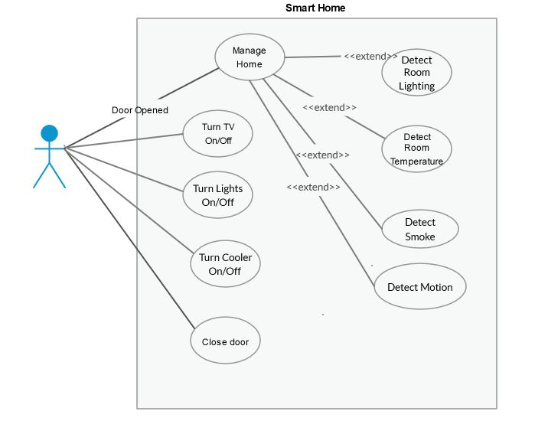

Figure 6. 1 Use case diagram

The user shall interact with the system using the mobile application. The user selects to open or close the door from the mobile application.

The user will be able to manage all the home appliances using the mobile application. The user can select which home appliance he/she wants to turn on/off at any time they want. The user can select the on/off button in the mobile application to manage the home appliances. The user can select to turn on/off the lights from the mobile application when he/she doesn’t need it overriding the system.

The user shall also be able to turn on/off the cooler/fan at their convenience by selecting the button in the mobile application.

The user shall be able to turn off the alarm when he/she is travelling or not at home or any other reason.

Table 6.1 Use case description

|  |  |  |
| --- | --- | --- |
| Use Case Name: | Turn on/off home appliance | |
| Use Case ID: | 1 | |
| Priority: | User | |
| Source: | User | |
| Primary Actor: | User | |
| Secondary Actor: | Mobile application | |
| Description: | The Use Case describes the process of turning on or off of the home appliances. The user can turn on/off the home appliances using the mobile application. The system receives the command from the mobile application and turns on/off the appliance. | |
| Pre-condition: | The home appliance is either on or off | |
| Trigger: | The scenario starts when a sensor or the user turns on or off the home appliance | |
| Typical Course of Events: | **Actor Action** | **System Response** |
| **Step 1:** User wants to turn on/off an appliance | **Step 2:** The mobile application sends the command to the system |
|  | **Step 3:** The system receives the command and turns on/off the home appliance |
| Alternative Courses: | The home appliance is already turned on by the sensors | |
| Conclusion: | The system turns on or off the home appliances when it is triggered by the user using the mobile application | |
| Post-Condition: | The user can view the status of all the devices on the mobile application | |
| Business Rule: | The mobile application can run only on Android smartphone | |
| Constrains Specification: | There must be an internet connection | |
| Assumptions: | The user has a smartphone  The user has an internet connection | |

## 6.2 SCREEN IMAGES

### 6.2.1 LOGIN SCREEN

This will be the user interface screen of the mobile application for the users to log in to the system using the username and password.

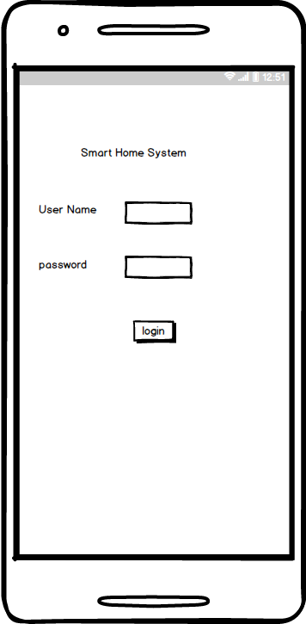

Figure 6. 2 Login interface

### 

### 6.2.2 INTERFACE FOR LIGHTS CONROL

This will be the user interface in the mobile application to allow users to select which lights they want to turn on/off.

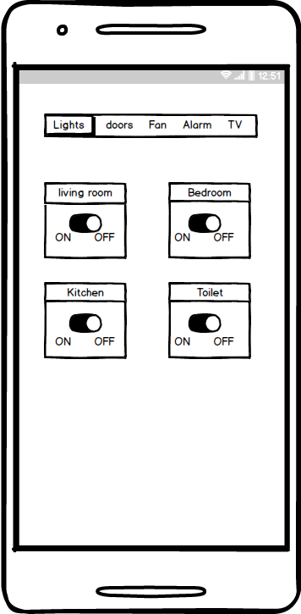

Figure 6. 3 Interface for lights

### 6.2.3 INTERFACE FOR DOORS

This will be the user interface to allow users to select which door they want to open or close using the mobile application.

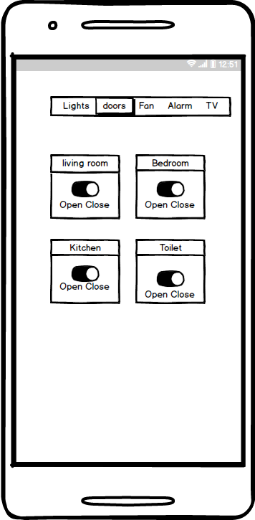

Figure 6. 4 Interface for controlling doors

### 6.2.4 INTERFACE FOR FAN

This user interface will allow users to turn on/off the fan and also control the speed of the fan.

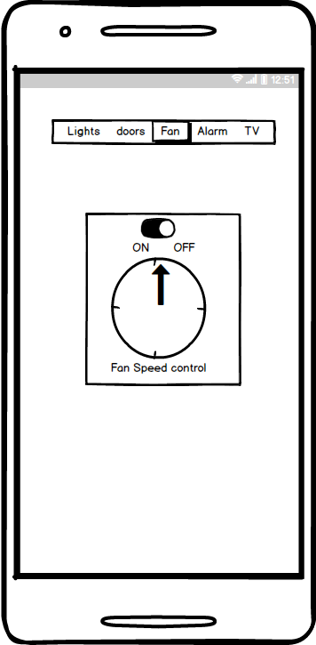

Figure 6. 5 Interface for controlling fan

## 6.3 SCREEN OBJECTS AND ACTIONS

The username and password fields in the Figure 6.2 will allow the user to enter the username and password to login to the system. By clicking on the login button the user will be logged in to the system and can now access all the functionalities of the system.

In Figure 6.3 we have a menu bar which will allow the user to select which device they want to interact with for switching it on/off. The living room object will allow the user to select the on/off button to turn on/off lights in the living room, the bedroom object will allow the user to turn on/off the lights in the bedroom, the kitchen object allows the user to turn on/off the lights in the kitchen, the toilet object will allow the user to turn on/off the lights in the kitchen. The on and off buttons will send information to the Arduino UNO micro-controller when the user selects it and the Arduino UNO will perform the actions accordingly.

In Figure 6.4 the user can control the doors by selecting the open or close buttons. The living room object allows the user to select open/close button to open/close the door of the house. The bedroom object allows the user to select open/close buttons to either open or close the door of the bedroom. The kitchen object will allow the user to select the open/close buttons to open or close the door of the kitchen. The toilet object will allow the user to select the open/close button for opening or closing of the toilet door. The open and close buttons will send information to the Arduino UNO micro-controller when the user selects it and the Arduino UNO will perform the actions accordingly.

In Figure 6.5 the object will allow the user to select on/off and also control the speed of the fan. The object will send information to Arduino UNO micro-controller and perform the actions accordingly and also increase or decrease the speed of the fan.

# 7. REQUIREMENTS MATRIX

Table 7. 1 Cross-reference of system components and functional requirements

|  |  |  |
| --- | --- | --- |
| SYSTEM COMPONENTS | FUNCTIONAL REQUIREMENT | NUMBER/CODE IN THE SRS |
| LIGHT SENSOR | The system should sense the light rays from the sun. | 4.1.3 |
| SMOKE SENSOR | The system should be able to send signals to the alarm in case of smoke/fire or break-in. | 4.4.3 |
| The system should detect smoke in the house. | 4.5.3 |
| TEMPERATURE SENSOR | The system should be able to read the room temperature. | 4.3.3 |
| MOTION SNESOR | The system should be able to detect movement in the house | 4.2.3 |
| MOBILE APPLICATION | The system should allow user to control all the features | 4.7.3 |
| DATABASE | It should be able to store the user details and the data received from the sensors. |  |
| ARDUINO UNO MICRO CONTROLLER | It should be able to receive information from the sensors and the mobile application and also send instructions to the devices. |  |